**LAPORAN ACTIVITY**

Mata Praktikum : Jaringan Komputer

Kelas : 3IA24

Praktikum ke- : 4

Tanggal : 7 November 2023

Materi : DNS & Mail Server

NPM : 50421704

Nama : Juan Samuel Christopher

Ketua Asisten : Madanil

Nama Asisten :

Paraf Asisten :

Jumlah Lembar : 7



**LABORATORIUM TEKNIK INFORMATIKA**

**UNIVERSITAS GUNADARMA**

**2022/2023**

**LISTING**

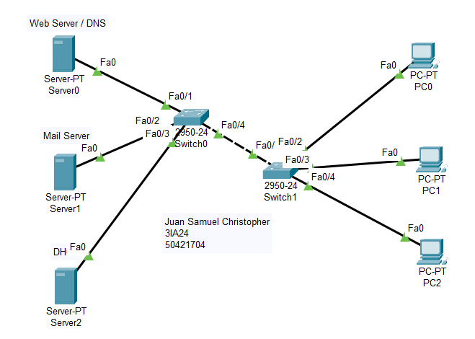

* **Web Server / DNS (Server 0)**

**Ip Config DNS Services**

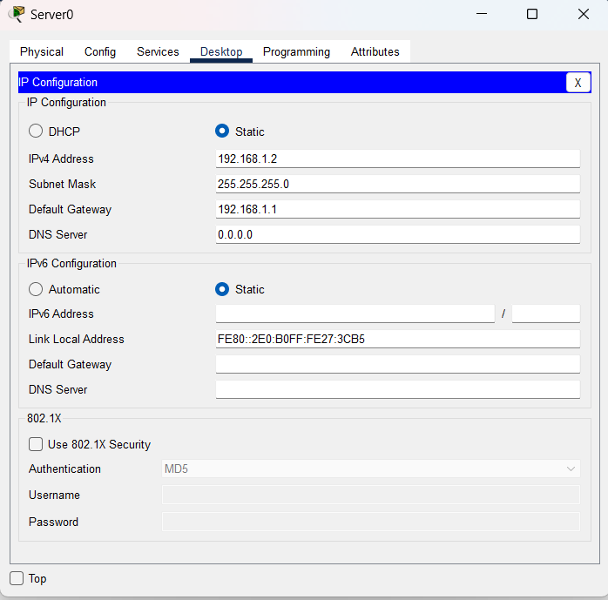 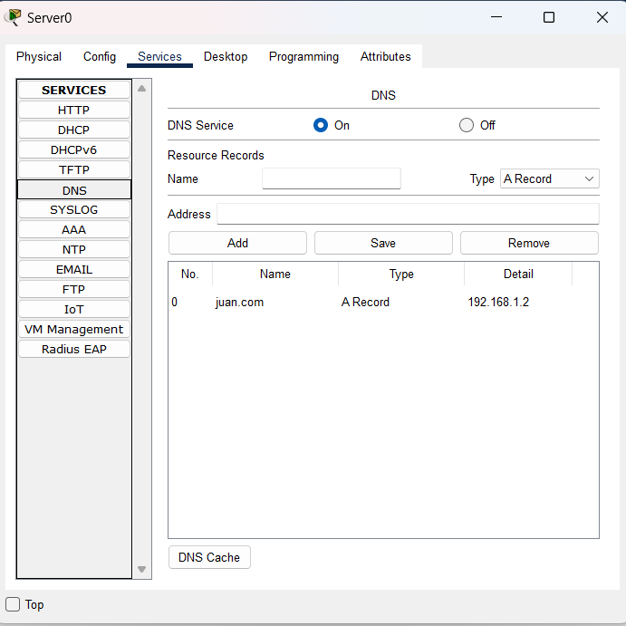

**HTTP Services**

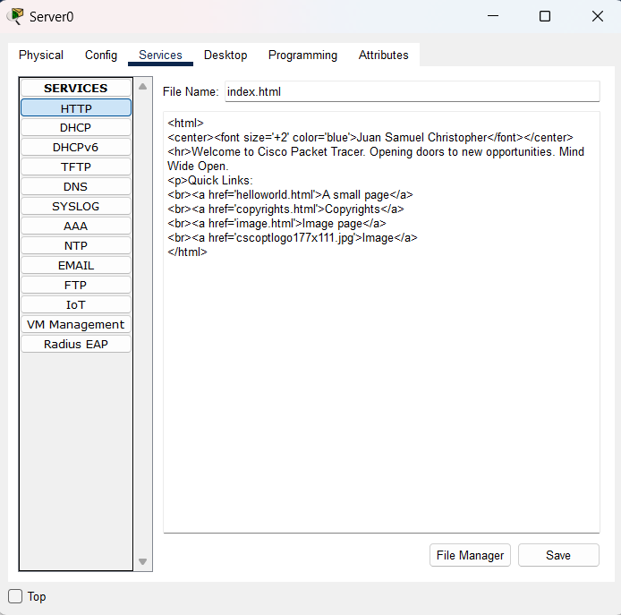

* **Mail Server ( Server 1)**

**IP Config Email Service**

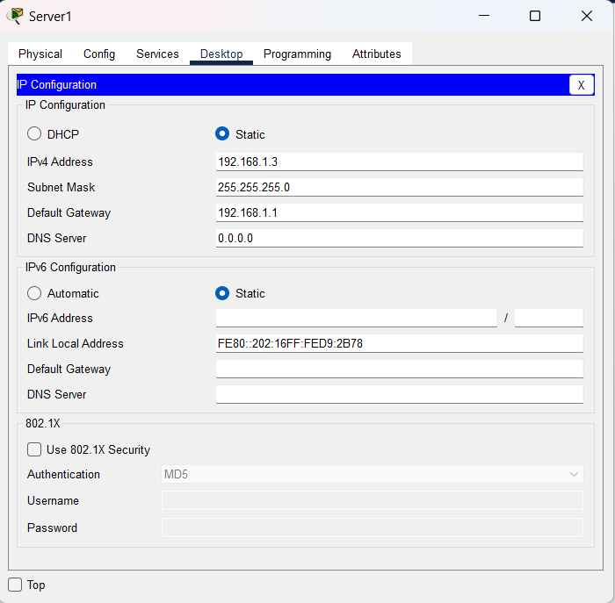 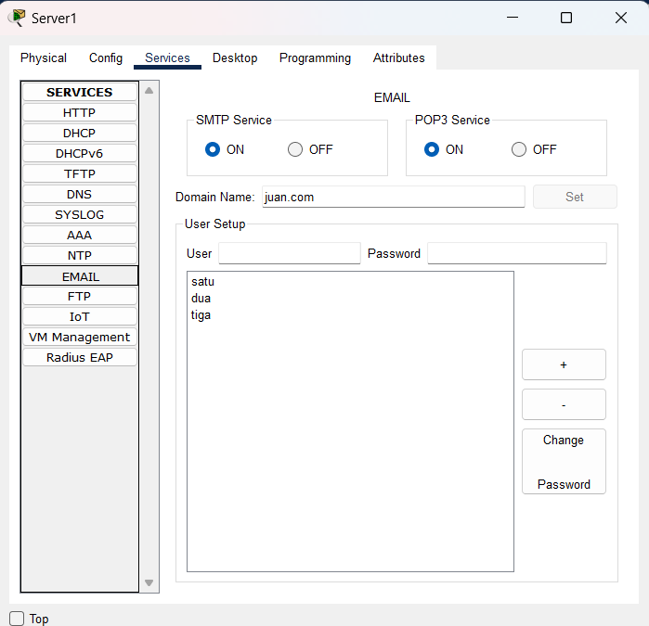

* **DHCP (Server 2)**

**Ip Config DHCP Services**

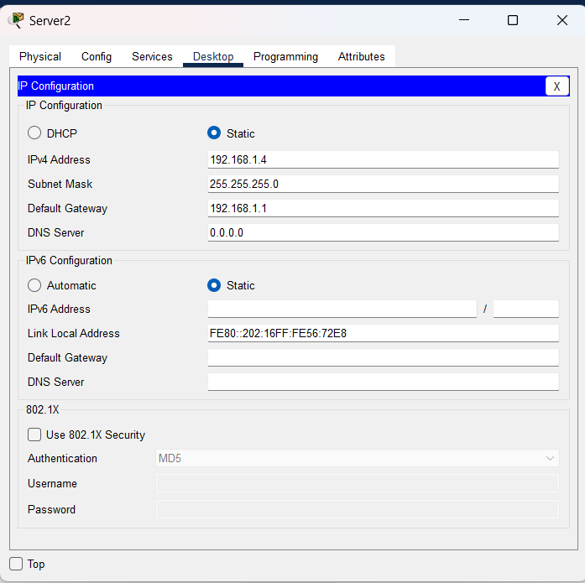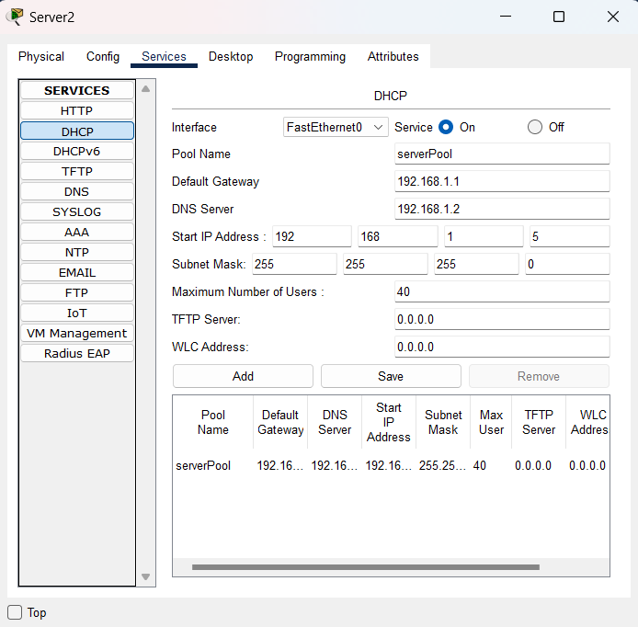

* **PC 0**

**Ip config Web Browser**

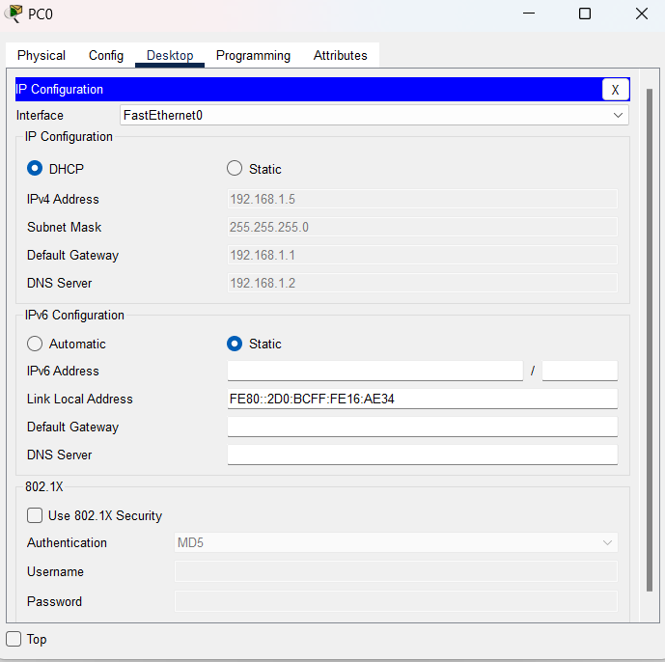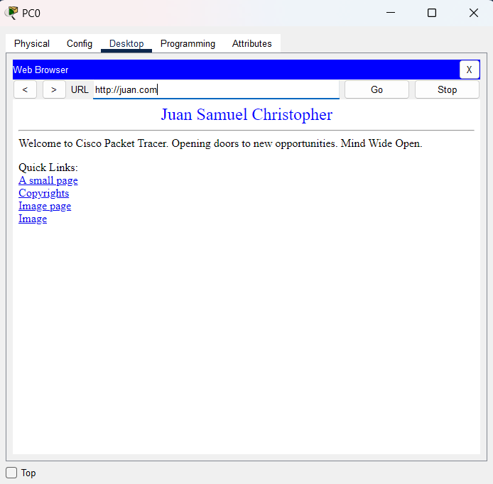

**Email kirim Email terima**

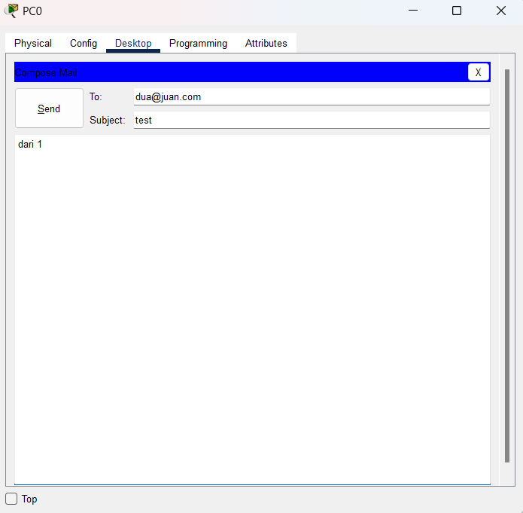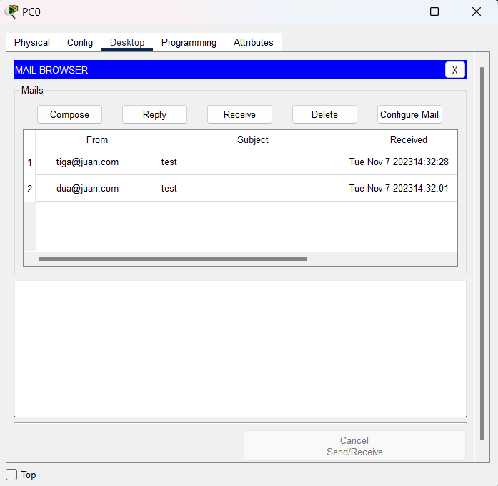

* **PC 1**

**Ip Config Web Browser**

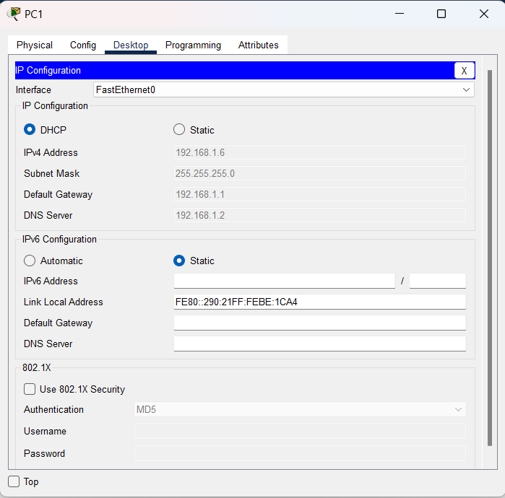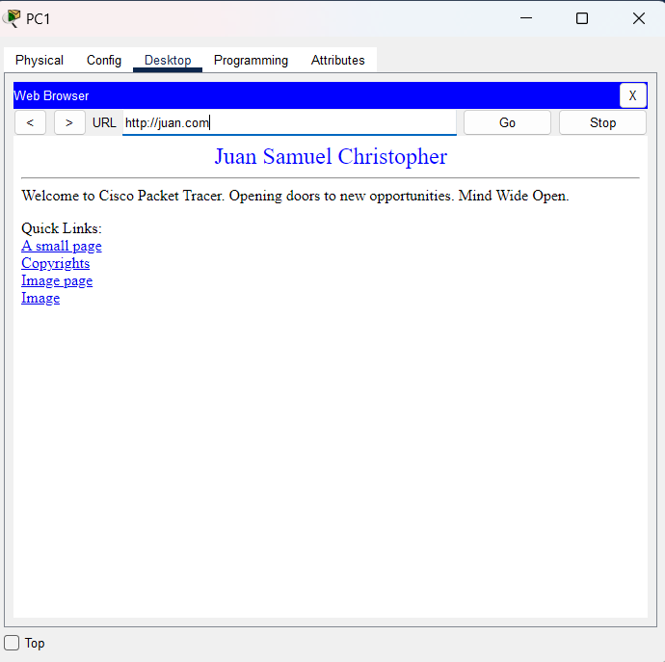

**Email Kirim Email Terima**

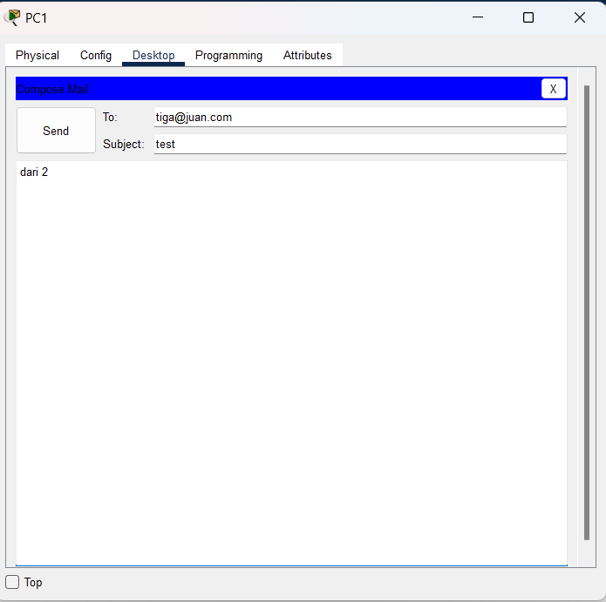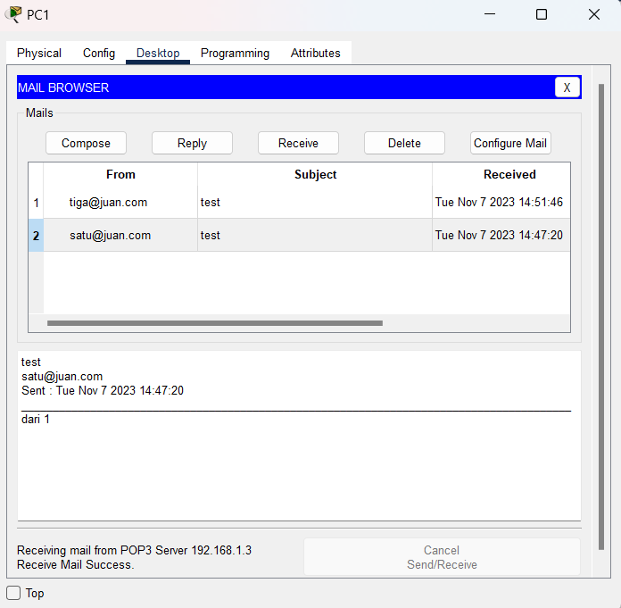

* **PC 2**

**Ip config Web Browser**

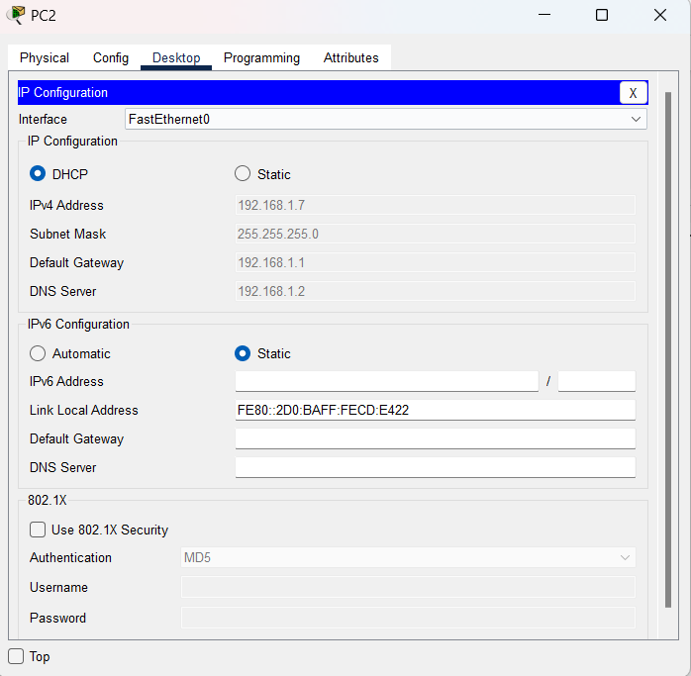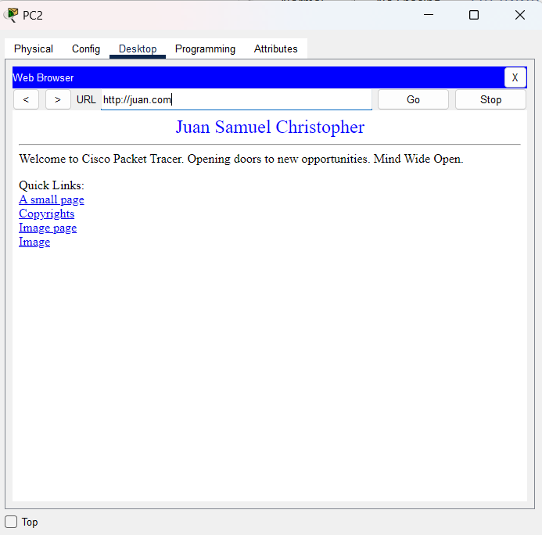

**Email kirim Email Terima**

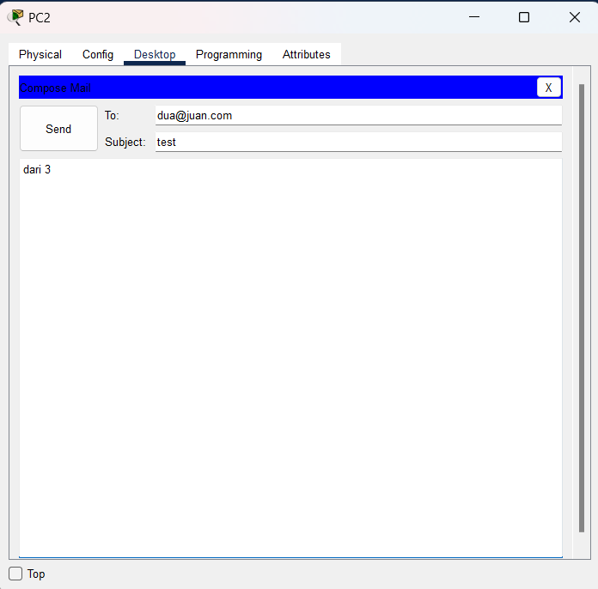 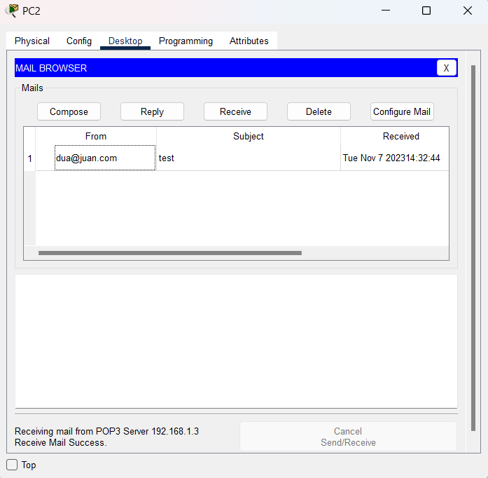

**OUTPUT**

